Day 4 - Dynamic Frontend Components - [Nike e-commerce]

The product listing page with dynamic data.

BUILDING DYNAMIC FRONTEND FOR MARKETPLACE Individual product detail pages with accurate routing and data rendering. Working category filters, search bar,

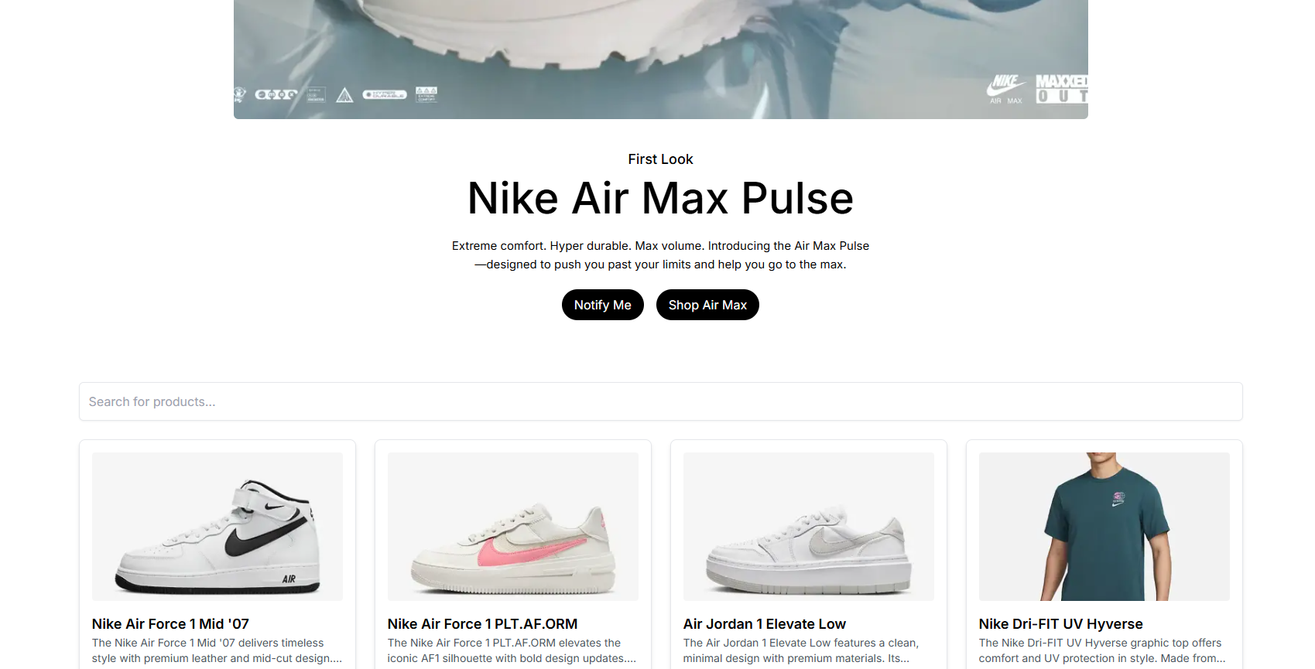

individual product detail pages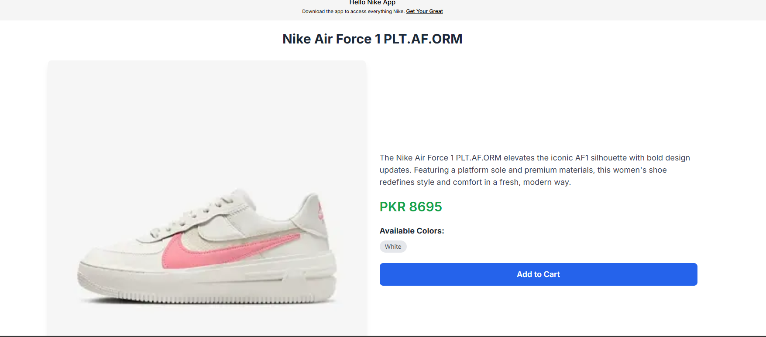 using dynamic routing in Next.js. • Include detailed fields such as:

o Product Description

o Price

o Available Sizes or Colors

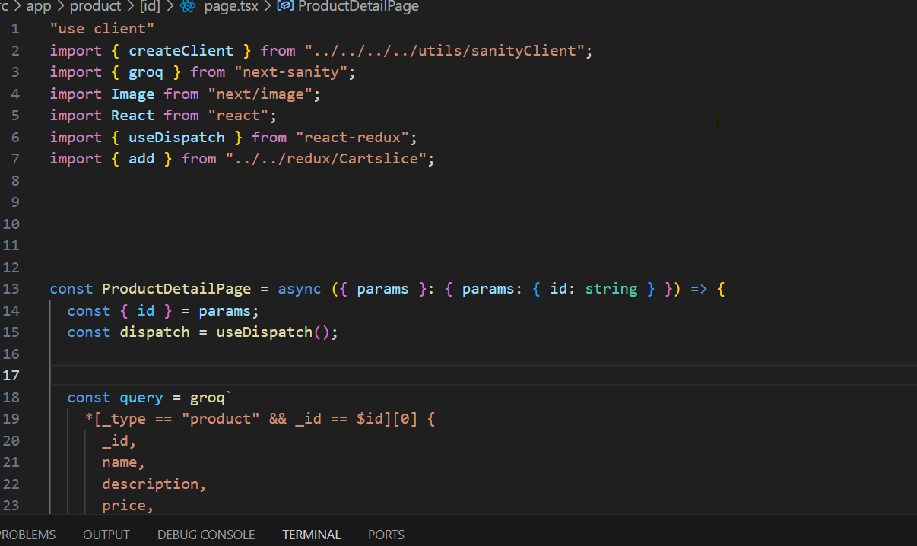

**ADD TO CART FUNCTIONALITY :**

Shows how much qunatities you have selected in header alongside with cart icon and you can increase or decrease as you wish

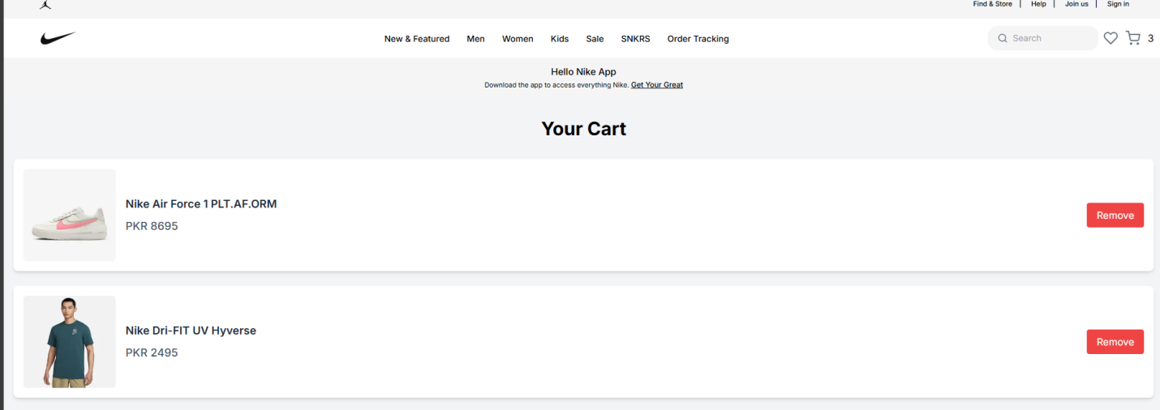

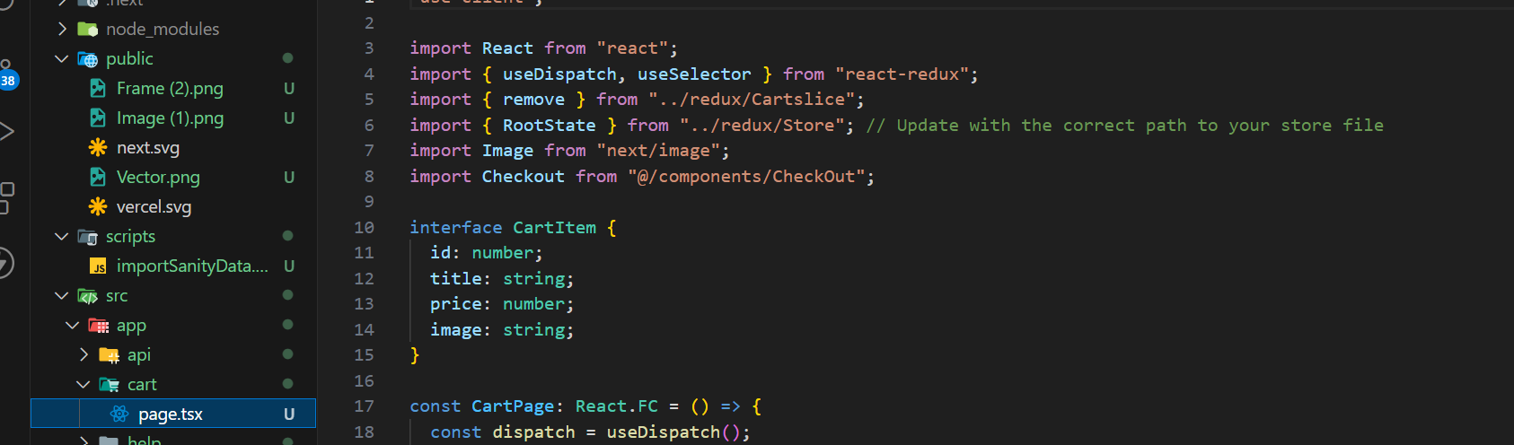

Checkout Flow Component: 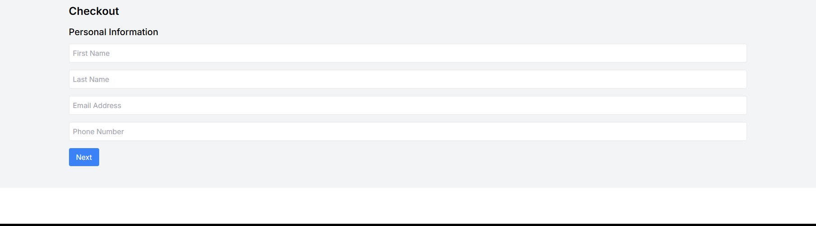

• Create a multi-step form for checkout, including fields for:

o Billing and shipping address

o Payment details

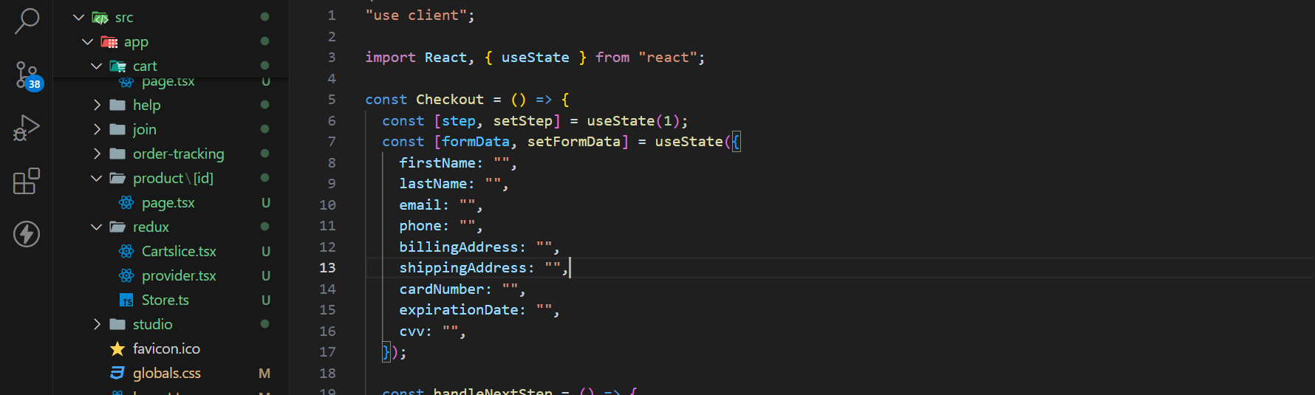

Search Bar: 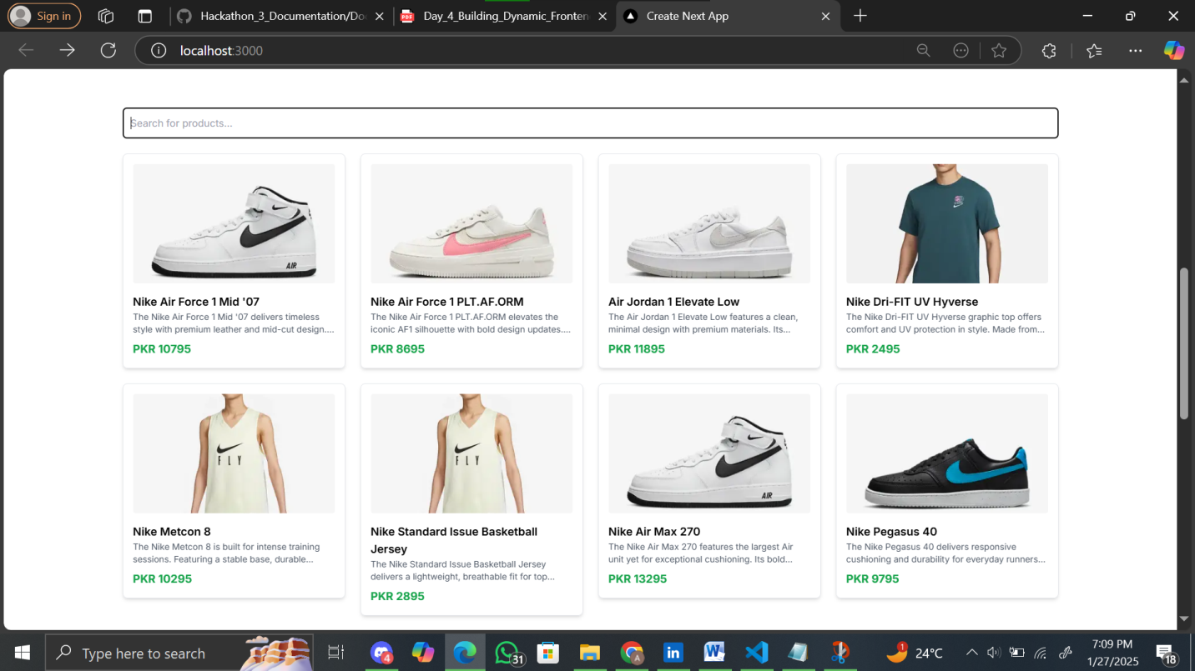

• Implement search functionality to filter products by name or tags

